**REVIEW-WEEK 29**

**I/ Look and match.**

**Cookie drink banana sandwich lunchbox**

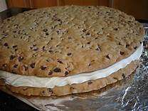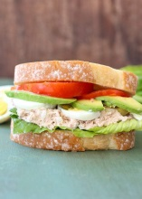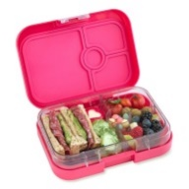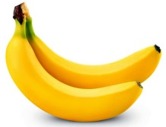

**II/ Complete the sentence.**

|  |
| --- |
| **have don’t have** |



**1/ I** …….. **two sandwich…>I have two sandwiches.**

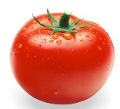

2/ I …………………..a banana.



3/ I……………….. my lunchbox.



4/ I………………….an apple.



5/ I…………………… two bananas.



6/ I …………………. a cookie.

**III/ Look and write.**

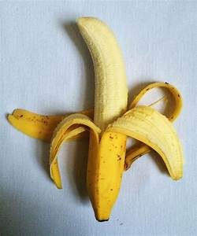

**1/ _ _ _ _ _ _...>banana**



2/_ _ _ _ _

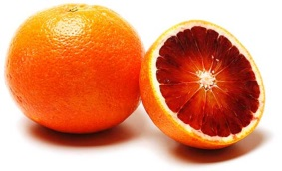

3/_ _ _ _ _ _

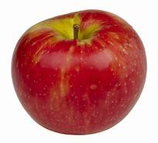

4/_ _ _ _ _



5/_ _ _ _ _ _ _ _



6/_ _ _ _ _ _ _ _

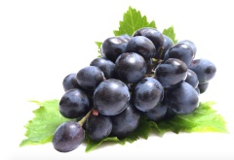

7/ _ _ _ _ _ _

8/_ _ _ _ _ _

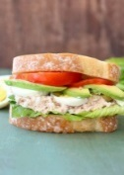**IV/ Write.**

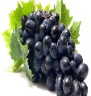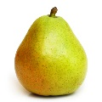

(1) (2) (3) (4)

Hello. I’m Hoa and I’m a student. It’s time for lunch. I’m hungry! I have a (1)…………….... One is a banana. One is an orange. I have a drink. It’s orange juice. I have a(2)……………….and a (3)………….. .I don’t have(4)……………today,but it’s a very nice lunch!

**V/ Underline the correct word.**

**1/ This is a/ an apple.**

2/ I have a/ two eggs.

3/ This is a/ three sandwiches.

4/ I have a/an orange.

5/ This is a/ four bananas.

6/ I have a/ an tomato.

**VI/ Write.**

**1/ I don’t have a banana. X**

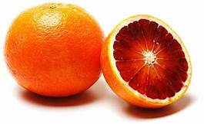

2/ I have…………………… **✓**

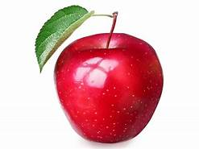

3/ ……………………………. **X**



4/ ……………………………….. **✓**

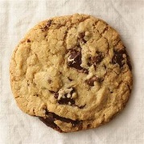

5/ …………………………… **X**